

**Sportsmen’s Tennis and Enrichment Center**

**Director of Marketing & Communications**

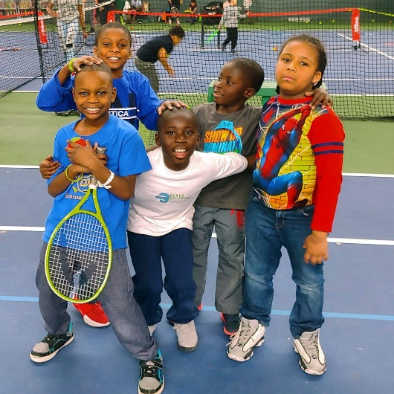Director of Marketing & Communications

Sportsmen’s Tennis & Enrichment Center

Dorchester, MA

## About Sportsmen’s Tennis & Enrichment Center

## Sportsmen’s Tennis & Enrichment Center builds leaders on the court, in the classroom and in the greater community by providing academic, wellness and social development programs alongside recreational and competitive tennis instruction for youth and adults. Sportsmen’s is committed to improving life opportunities for youth in Boston’s Blue Hill Corridor while welcoming a diverse community from the Greater Boston area.

As the first of its kind in the US, Sportsmen’s is an indoor, non-profit tennis club that was created by and for an African American Community. A premier facility and one that is inclusive of a uniquely diverse membership, Sportsmen’s maintains a focus on equity and access, while welcoming individuals from all walks of life. Sportsmen’s continues to be a leader and innovator in efforts to transform a challenged and under-resourced community. Among many accolades, the US Tennis Association has recognized

Sportsmen’s with the National Junior Tennis & Learning Chapter of the Year, Organization of the Year,

and the ICON Award winner for increasing diversity in tennis.

Sportsmen’s 4-acre facility on the Dorchester/Mattapan line currently hosts 14 tennis courts, The Learning Center (TLC) at Sportsmen’s, and the Center for Community Wellness (CCW), which holds a fitness area and community health programs. Sportsmen’s $4.6M annual operating budget consists of 38% fee-for-service revenue, with the remaining operating funds and capital investments secured through philanthropy. In 2024, Sportsmen’s was honored to be recognized with a $2M gift from MacKenzie Scott’s Yield Giving Campaign.

Through a $22M Capital Campaign currently underway, Sportsmen’s will dramatically expand its facility and programs. Phase 1 of the Campaign, a $10M addition and renovation, has been completed, Fundraising for the second phase is underway.

Sportsmen’s core programs serve over 6,000 residents (pre-Covid) annually and include:

* **THE LEARNING CENTER:** a comprehensive suite of out-of-school time educational and social enrichment programs

that works to close the performance gap among students in our community

* **YOUTH TENNIS:** youth tennis clinics, camps and lessons place local, low-income and/or

minority youth on an intentional developmental pathway to college/post-secondary level high-performance tennis.

* **ADULT TENNIS:** Adults play a pivotal role in furthering the Sportsmen’s mission. 400 adult

members provide a deep sense of community, a source of revenue and a diverse pool of

committed volunteers, while helping adults maintain an active lifestyle.

* **HEALTH AND WELLNESS:** Sportsmen’s offers a range of free health and wellness programs

within the Center for Community Wellness (CCW), focused on helping residents understand the

social determinants of health, and empowering them with knowledge and the tools to make

incremental changes. CCW includes a fitness center which offers free fitness classes and access

to cardiovascular and weight training equipment.

For more information on Sportsmen’s Tennis and Enrichment Center, please visit https://sportsmenstennis.org.

## 

## 

## The Director of Marketing & Communications Opportunity

Sportsmen’s is seeking a passionate, mission-driven Marketing & Communications professional skilled in digital and traditional marketing channels to elevate our profile, build brand awareness, and celebrate our achievements. This person will possess an eagerness to learn about the challenges our community faces and to amplify our outreach and success across all program areas as well as strong project management skills.

**Responsibilities**

* Create and execute a comprehensive marketing plan and brand strategy, establishing key performance indicators (KPIs) to measure the success of marketing campaigns and initiatives;
* Manage Sportsmen’s brand identity and messaging across all channels to ensure consistency and effectiveness;
* Maintain a robust media outreach list, elevate awareness of Sportsmen’s and all programs, and

increase our PR/marketing footprint across regional media channels;

* Develop print and digital materials, including emails, development communications, annual

report and appeal letters, website content, Capital Campaign collateral, CEO Newsletters,

annual donor reports, and event collateral;

* In partnership with contractual staff, execute and monitor social media on multiple channels that activates users and creates a culture of engagement and philanthropy;
* Serve as a strategic partner to program directors to track key metrics, outcomes, and stories to

best tell the Sportsmen’s story externally, and identify and communicate appropriately with

segmented Sportsmen’s audiences;

* Collaborate with program staff and funders on philanthropic stewardship announcements (press

release, toolkit, social launch, etc.), and with the COO on website maintenance;

* Staff and manage the Marketing Committee, paying particular attention to Board Relations;
* Supervise contractual staff, including Social Media coordinator, graphic designer and webmaster;
* Coordinate with relevant stakeholders to plan and execute successful media events and publicity campaigns;
* Stay up-to-date with industry trends and best practices in marketing and communications;
* Represent Sportsmen’s at relevant community events and conferences;
* Other duties as assigned.

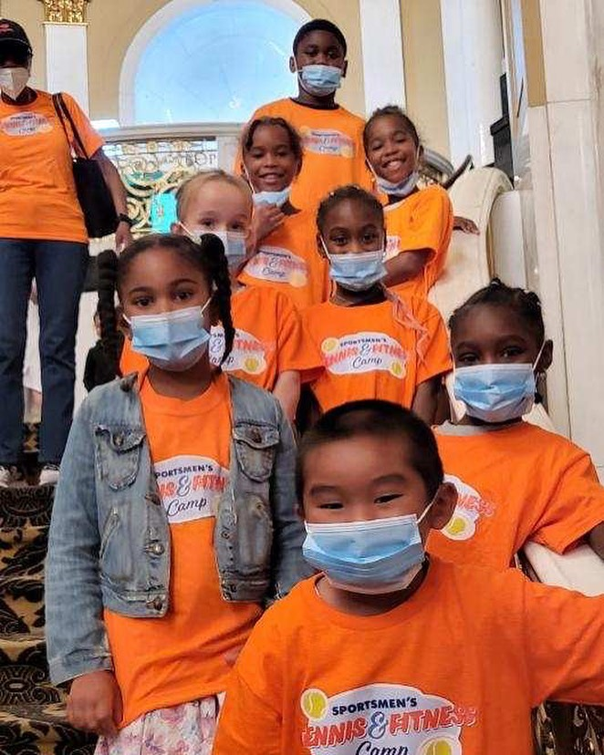

**Reporting Structure**

The Director of Marketing and Communications reports directly to the Chief Executive Officer and supervises contracted team members.

**Competencies**

* 5+ years of marketing and communications experience in a nonprofit setting, with demonstrated success in establishing and executing strategic plans for marketing and communications;
* Strong understanding and experience with social media and how it contributes to an

organization’s overall goals, including growth, revenue-generation and storytelling

* Strong interpersonal, written and verbal communication skills;
* A comfort with and asset-based approach to working with an ethnically, culturally, and socioeconomically diverse population;
* Familiarity with content and marketing tools such as Adobe (Photoshop, In Design, Premiere

Pro), Canva, Microsoft Office, Google Analytics; and

* A passion for social justice, equity and youth development.

**Additional Characteristics**

* Engenders trust in building relationships through strong listening skills and a high level of emotional intelligence;
* Demonstrates a team-oriented and collaborative leadership style, with experience working in small teams;
* Leads with a sense of joy and fun as well as purpose; and
* Thrives in an entrepreneurial, fast-paced, and dynamic environment

## Compensation & Benefits

The salary range for this position is $90,000 to $100,000. Sportsmen’s offers a comprehensive, competitive compensation package, including health, dental, vision and life insurance, short- and long-term disability, and a 401(k) program with a 3% match.

*Sportsmen’s is an equal opportunity employer. Since our inception, we have been committed to*

*encouraging and welcoming diversity throughout the organization. We do not discriminate in*

*employment opportunities, policies or practices on the basis of race, color, religion, sex, national*

*origin, age, disability, veteran status, sexual orientation, marital status, or any other characteristic*

*protected by law. It is our policy to employ persons on the basis of ability, experience, education,*

*and character. Our policy regarding equal employment opportunity applies to all aspects of*

*employment, including recruitment, hiring, job assignments, promotion, compensation, working*

*conditions, scheduling, wage and salary administration, performance evaluation, benefits,*

*professional development, disciplinary action, and termination.*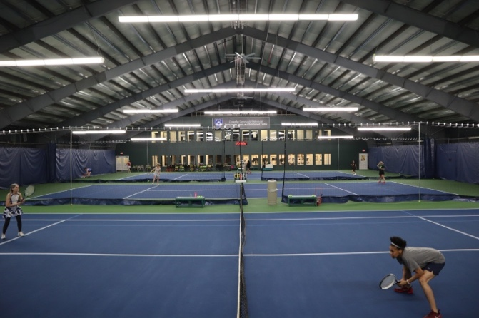

## Contact

Maureen Alphonse-Charles and Kirstin Griffiths of Koya Partners, the executive search firm that specializes in mission-driven search, have been exclusively retained for this search. To express interest in this role, please submit your materials by [filling out the Talent Profile](https://talent-profile.diversifiedsearchgroup.com/search/v2/21288), or email Kirstin Griffiths directly at [kgriffiths@koyapartners.com](mailto:kgriffiths@koyapartners.com). All inquiries and discussions will be considered strictly confidential.

Koya Partners is committed to providing reasonable accommodation to individuals living with disabilities. If you are a qualified individual living with a disability and need assistance expressing interest online, please email [NonprofitSearchOps@divsearch.com](mailto:NonprofitSearchOps@divsearch.com). If you are selected for an interview, you will receive additional information regarding how to request an accommodation for the interview process.

## About Koya Partners

Koya Partners, a Diversified Search Group company, is the nation’s premier search firm dedicated to mission-driven leadership. Since its founding in 2004, Koya has had an exclusive focus on mission-driven clients and was founded on the belief that the right leader can transform an organization and have a deep and measurable impact on our world. Koya works with nonprofits & NGOs, responsible businesses, and social enterprises in local communities and around the world.

Diversified Search Group is consistently recognized by Forbes on its top 10 list of “America’s Best Executive Recruiting Firms” and is an industry leader in recruiting transformational leaders for a changing world. The firm is deliberately different in its approach, with best-in-class teams who have decades of experience in cultivating inclusive leaders, understanding the dimensions of diversity, and building equitable teams.

Learn more about Koya Partners l Diversified Search Group via the [firm's website](https://diversifiedsearchgroup.com/koya-partners/).